

# KIDS ZONE

**Supervisor:** *NGUYỄN HẠ VY*

**Semester:** *01*

**Batch No:** *T3.2308.A0*

**Group No:** *02*

|  |  |  |
| --- | --- | --- |
| **Order:** | **Full name** | **Roll No.** |
| *1.* | *Nguyễn Hoàng Vĩ* | *Student1507766* |
| *2.* | *Huỳnh Mai Thảo Vy* | *Student1507647* |
| *3.* | *Nguyễn Hoàng Khánh Nhật* | *Student1507674* |
| *4.* | *Nguyễn Gia Bảo* | *Student1507675* |

***Month****: 11* ***Year****: 2023*

This is to certify that

**Mr. NGUYỄN HOÀNG VĨ Mr. HUỲNH MAI THẢO VY Mr. NGUYỄN HOÀNG KHÁNH NHẬT**

**Mr. NGUYỄN GIA BẢO**

Have successfully Designed & Developed

# KIDS ZONE

**-------------------------------------------**

Submitted by:

**Mr . Nguyen Hoang Vi**

**----------------------------------------------------------------**

Date Of Issue: 22/12/2023

-----------------------

Authorized Signature: Mr. Nguyen Hoang Vi

-----------------------

**CONTENT**

Review1............................................................................................................................

Review2............................................................................................................................

Review3............................................................................................................................

Tasksheet..........................................................................................................................

**ACKNOWLEDGE**

As we understand that the eProject is a step-by-step learning environment that closely simulates the classroom and Lab-based learning environment into actual implementation. It is a project implementation at your fingertips!! An electronic, live juncture on the machine that allows you to.

* Practice step by step i.e. laddered approach.
* Build a larger more robust application.
* Usage of certain utilities in applications designed by user.
* Single program to unified code leading to a complete application.
* Learn implementation of concepts in a phased manner.
* Enhance skills and add value.
* Work on real-life projects.
* Give a real-life scenario and help to create applications that are more complicated and useful.
* Mentoring through email support.

First of all, I would like to thank India Aptech for allowing my team to work on this fantastic eProject. We had a great experience with eProject this time.

Next, We would like to express my special thanks to our mentor, Ms. Ha Vy for the time and effort that she provided throughout the project. Your helpful advice and suggestions were beneficial to us during the completion of the project. In this respect, We are forever grateful to you.

Besides several mistakes we made in the project, we hope to have more opportunities to widen our knowledge in the web-developing world.

We will try to continue to learn and improve ourselves even more in the future.

Yours sincerely,

Team Group 2

**SYNOPSIS**

The Objective of this program is to give a sample project to work on real life

projects. These applications help you build a larger more robust application.

The objective is not to teach you JavaScript/Dreamweaver but to provide you with a

real life scenario and help you create basic applications using the tools.

You can revise the chapters before you start with the project.

This project is meant for students who have completed the module of HTML5. These

programs should be done in the Lab sessions with assistance of the faculty if

required.

It is very essential that a student has a clear understanding of the subject. Students

should go through the project and solve the assignments as per requirements given.

Kindly get back to eprojects@aptech.ac.in in case of any doubts regarding the

application or its objectives.

**PROBLEM DEFINITION**

The www.kids-Zone website is designed for the Kids (Toddlers) for Learning ABC’s in

more creative way. The website includes the ABC with A for …., B for….

Also it includes some nursery rhymes with images so that child can grasp more

easily. One two three till 100 with and without spellings, some basic calculation of

addition and subtraction. Prayers, Galleries of basic animals, plants, fruits, games

colors, Sunday-Mondays and so on.

The website is to be developed for the Windows Platform using HTML5, JavaScript

and Geolocation. The site should work well in all leading browsers including Chrome,

IE, Firefox etc.

Requirement Specification:

The Web site is to be created based on the following requirements.

1) Home page must be designed by including various interactive images like of a

child say prayer, brushing teeth, drinking milk and so on.

2) Navigation links must be included and must be designed in an interactive way

so as to become more user friendly for the kids.

3) Font sizes must be selected appropriately thinking about the end users.

4) Navigation must be made user friendly.

5) Menus can be included such as :

- ABC.s

- abc.s

- 123….

- Table of 2, 3,4, 5

- Some nursery rhymes with relevant images.

- Basic colors

- Some animals

- Some Vegetables

- Addition (here allow the end user to enter the value and message

must be prompted whether correct ans or incorrect)

- Subtraction (here allow the end user to enter the value and message

must be prompted whether correct ans or incorrect)

6) Look and feel must be made user friendly.

7) Uniformity and Navigation must be made smooth throughout the website.

8) The “Contact Us” page should have the Address of the Company and the mail

address which when clicked will invoke the local mail client from where they

can send an email. Address of the Company should be displayed using

GeoLocation API (eg. GoogleMaps).

**Hardware/ Software Requirements**

**Hardware**

A minimum computer system that will help you access all the tools in the

courses is a Pentium 166 or better

64 Megabytes of RAM or better

**Software [Either or Combination as per Course/Sem]**

• Notepad/HTML editor/CoffeeCup

• Angular / Angular JS / React / BootStrap

• Dreamweaver / Figma

• MS IE / Chrome / FireFox / Netscape /MS Edge

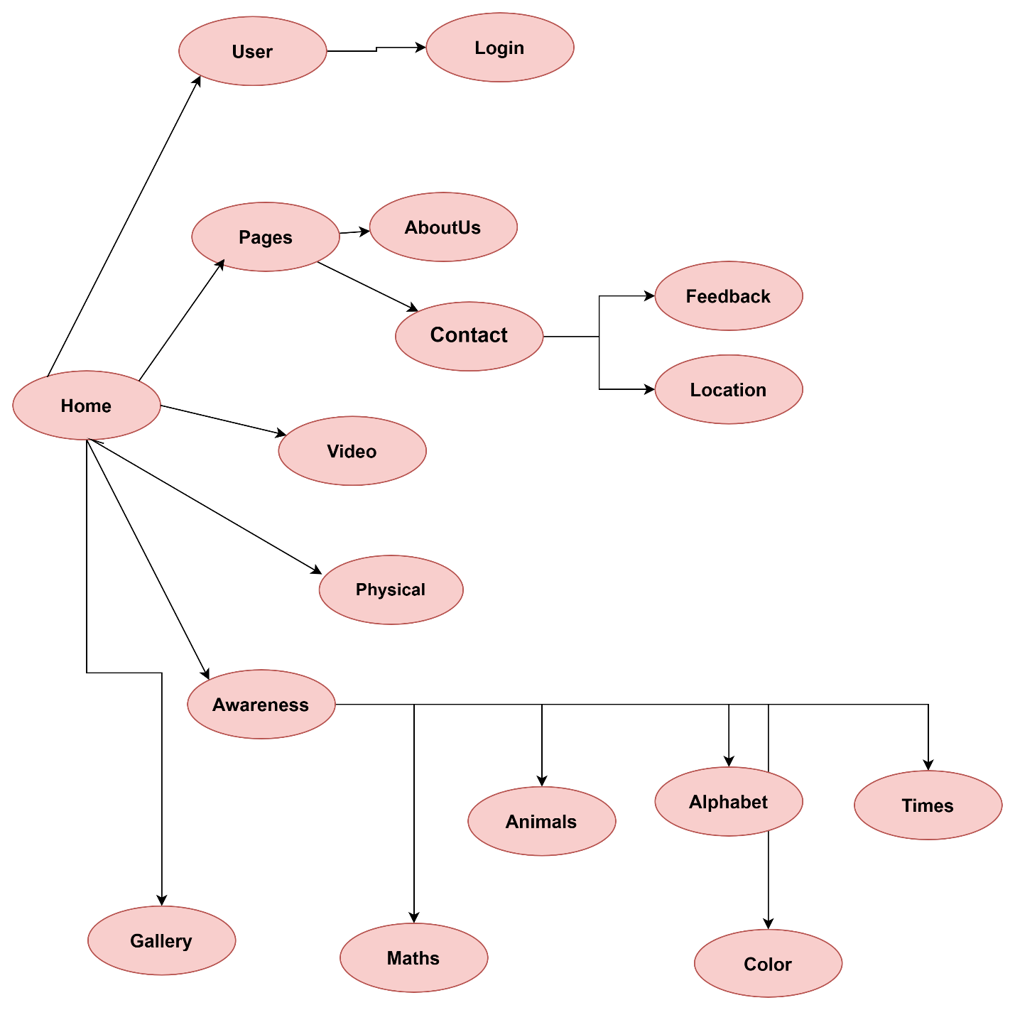

1. **Interactive with web at Homepage**

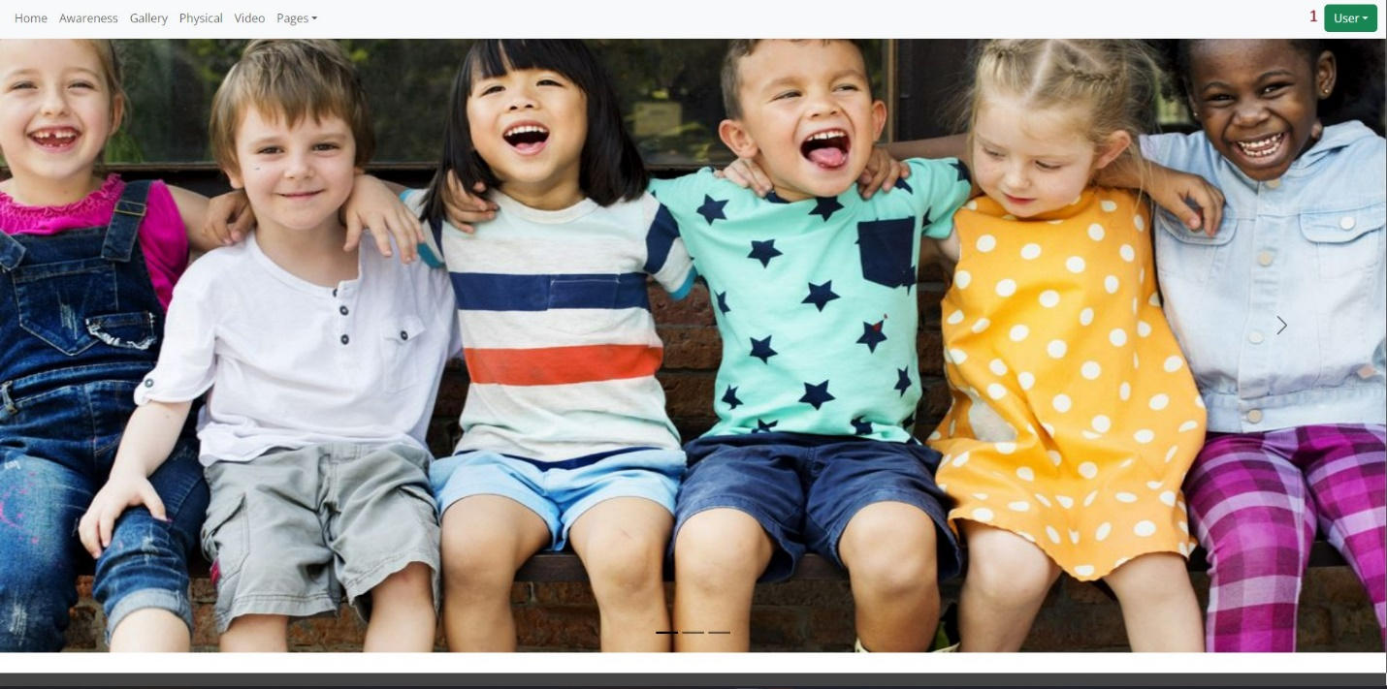

|  |  |  |  |
| --- | --- | --- | --- |
| **No.** | **Type** | **Discription** | **Name** |
| **1** | Click | -If you are not logged in, there will be no physical page. | User |

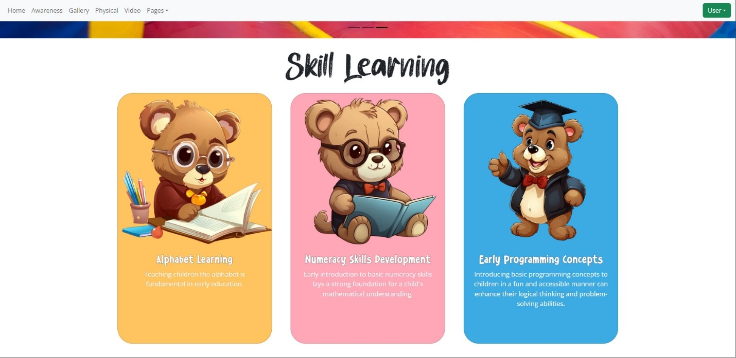

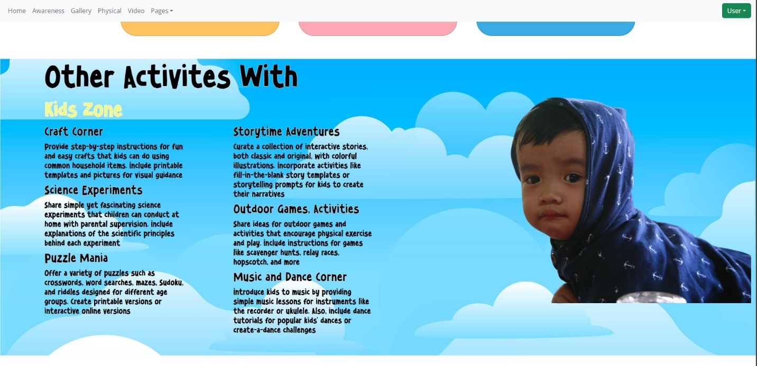

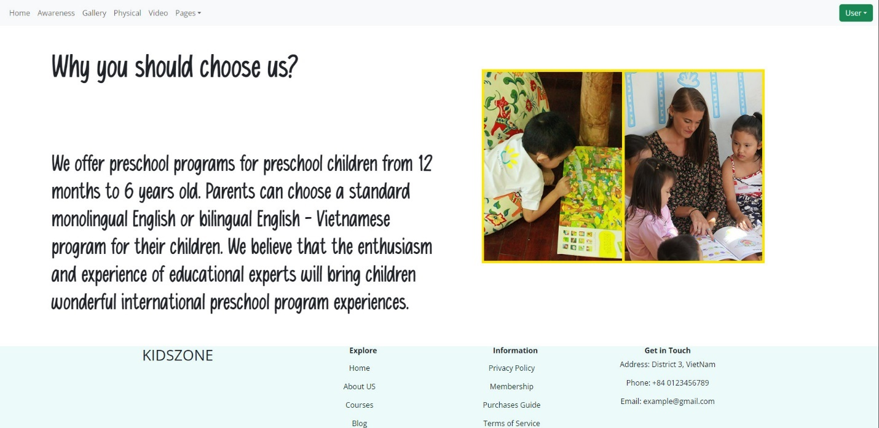

1. **Awareness**

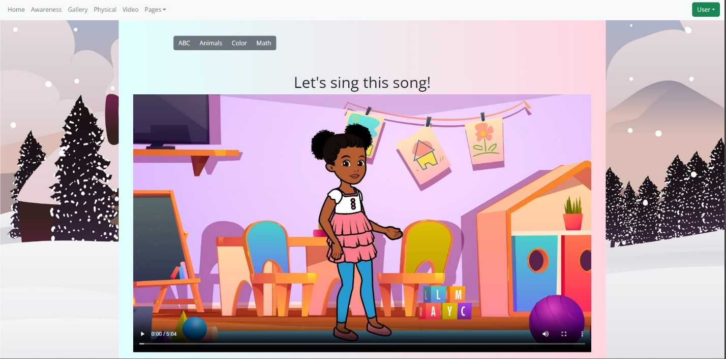

|  |  |  |  |
| --- | --- | --- | --- |
| **No.** | **Type** | **Discription** | **Name** |
| **1** | Click | -When click awareness, it will show you awareness page. | Awareness page |

**ABC:**

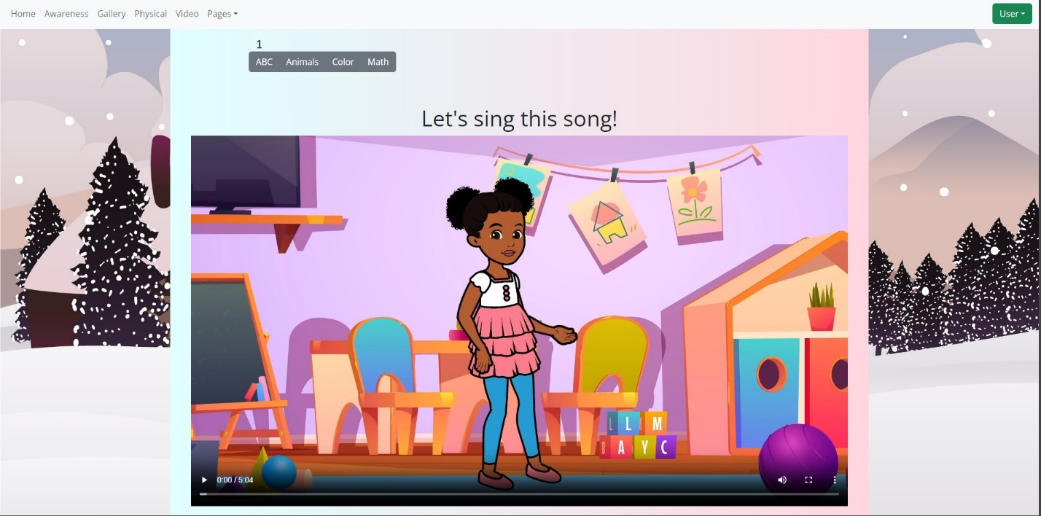

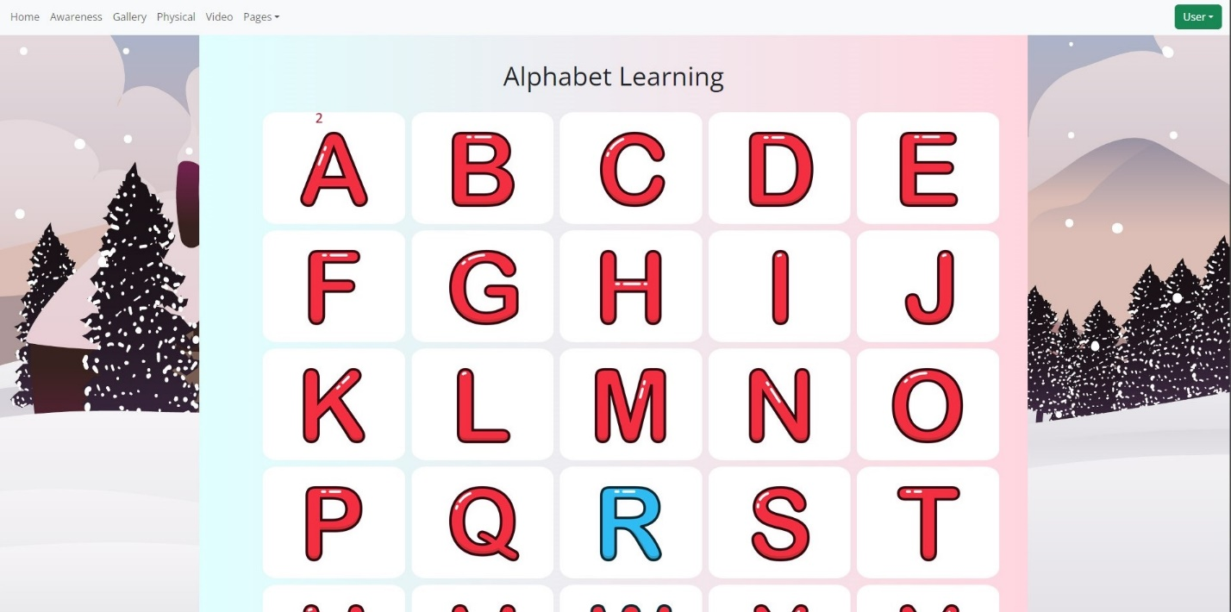

|  |  |  |  |
| --- | --- | --- | --- |
| **No.** | **Type** | **Discription** | **Name** |
| **1**  **2** | Click  Click | -When you click on the box, it will show you the alphabet learning.  -When you click on the picture, it will make a sound. | Alphabet learning |

**Animal:**

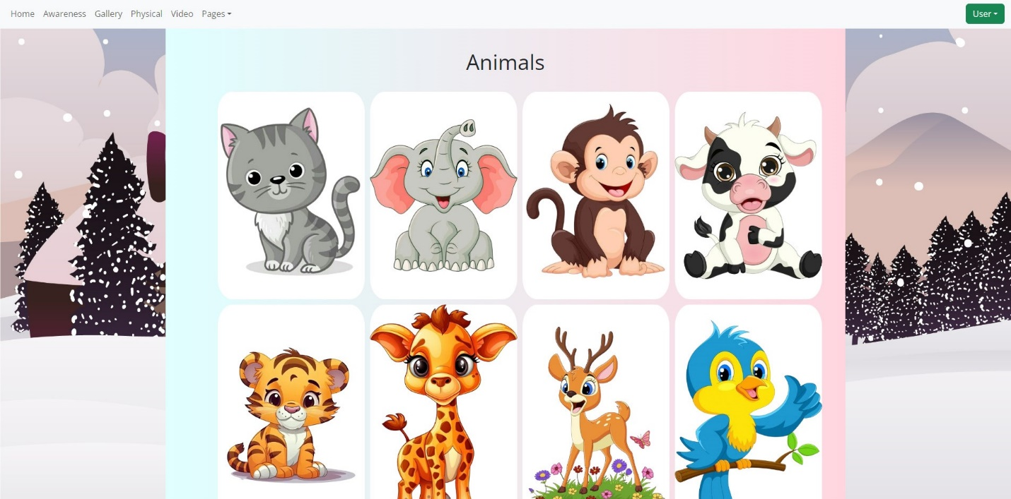

-When you click on the picture, it will make a sound.

**Color:**

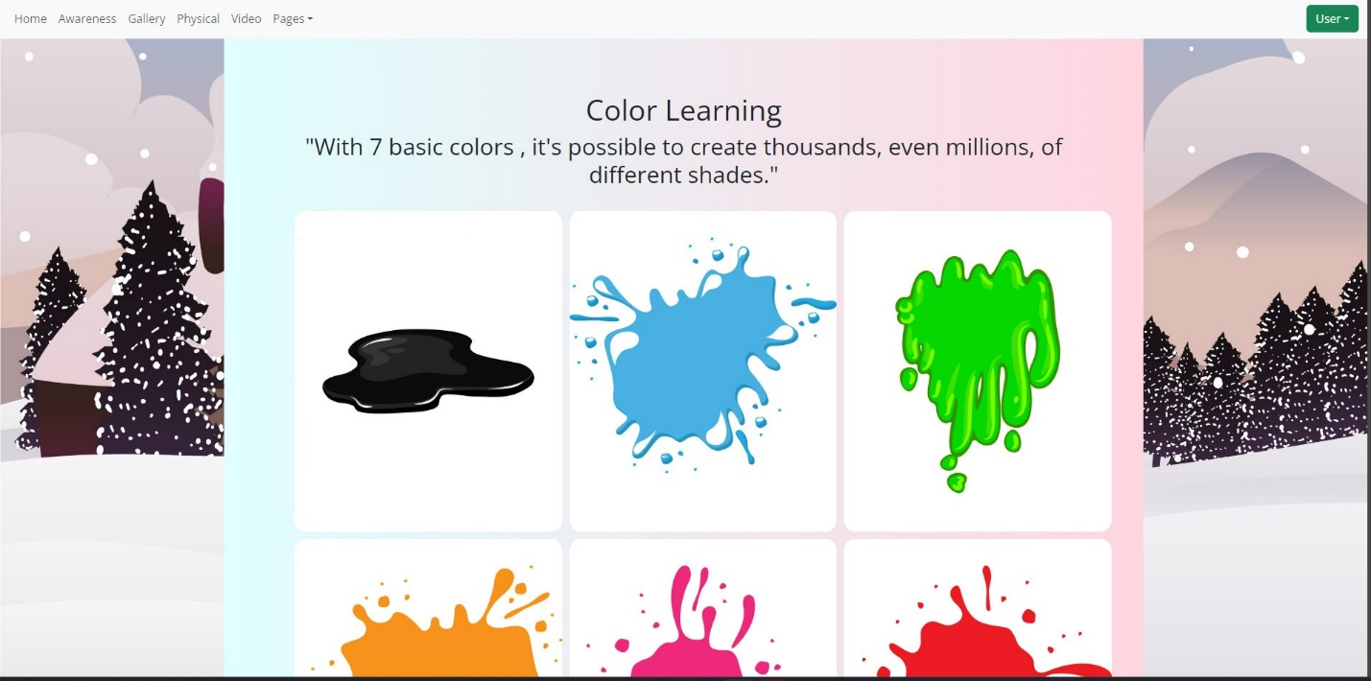

-When you click on the picture, it will make a sound.

**Math:**

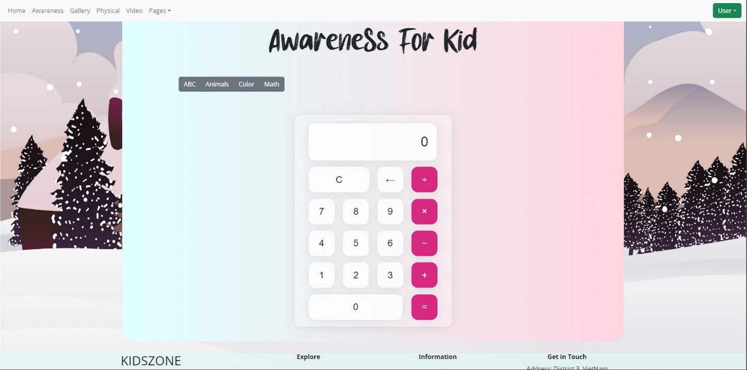

-We set up maths, kids can learn basic math operations such as addition, division,...

1. **Gallery page**

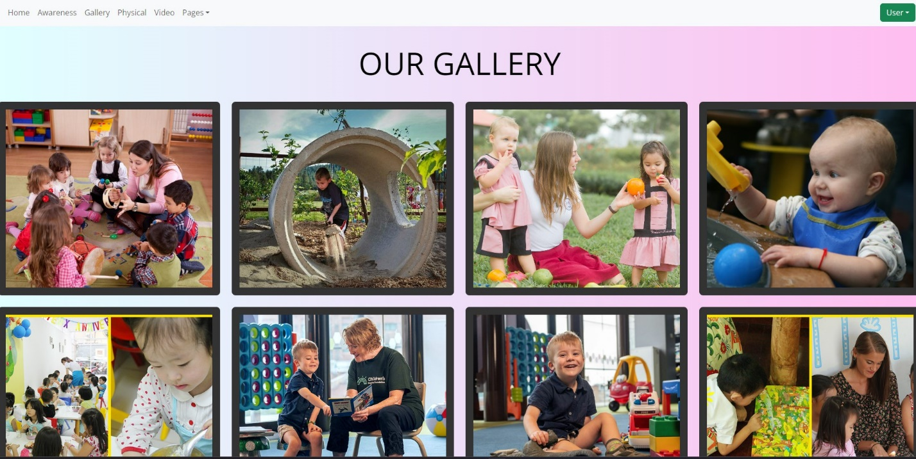

1. **Physical page**

**Blogs and Blog details :**

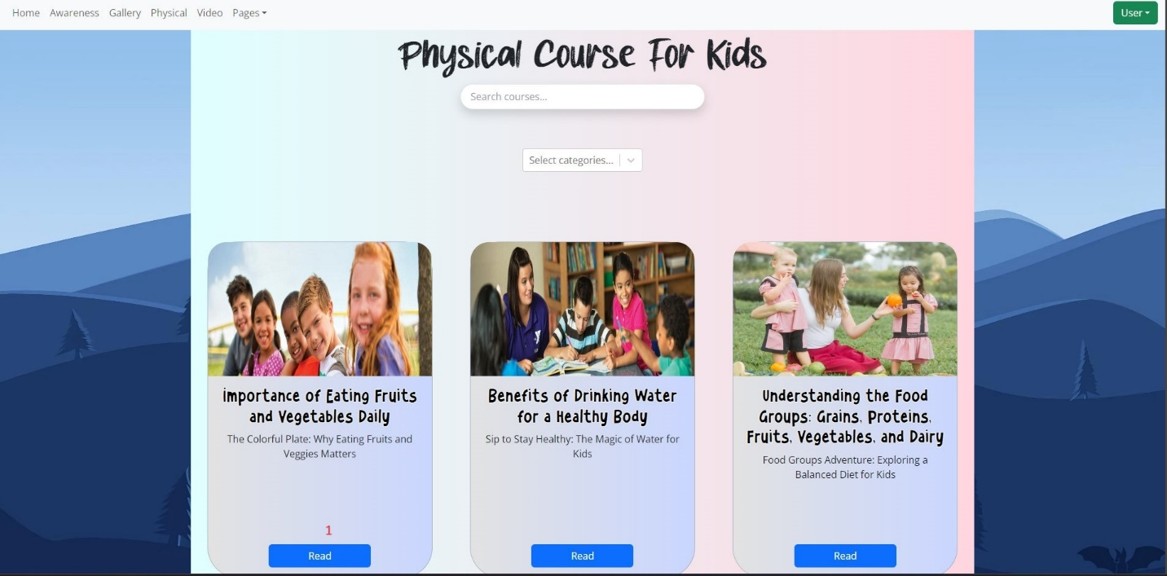

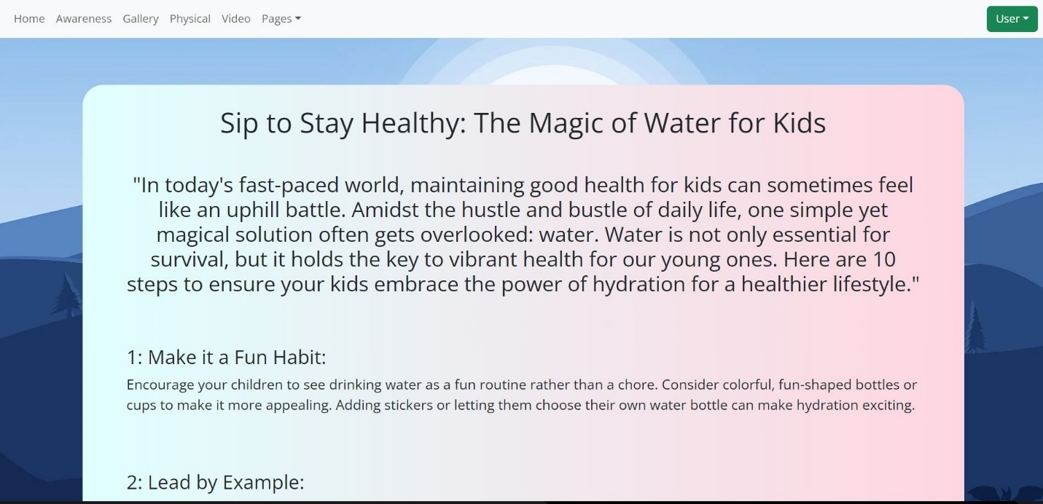

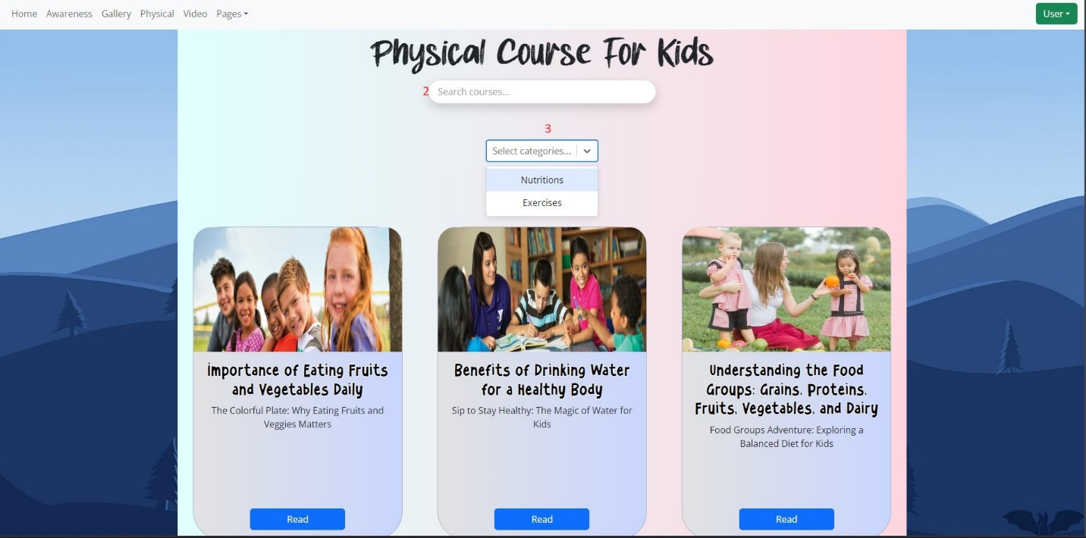

|  |  |  |  |
| --- | --- | --- | --- |
| **No.** | **Type** | **Discription** | **Name** |
| **1** | Click | - When you click Read, it will show blog detail. | Physical course. |
| **2** | Input | -When you search, there are 2 categories: Nutrition and Exercises. | Search bar |
| **3** | Input | - When you select categories, it will filter by categories. | Categories option |

1. **Video page**

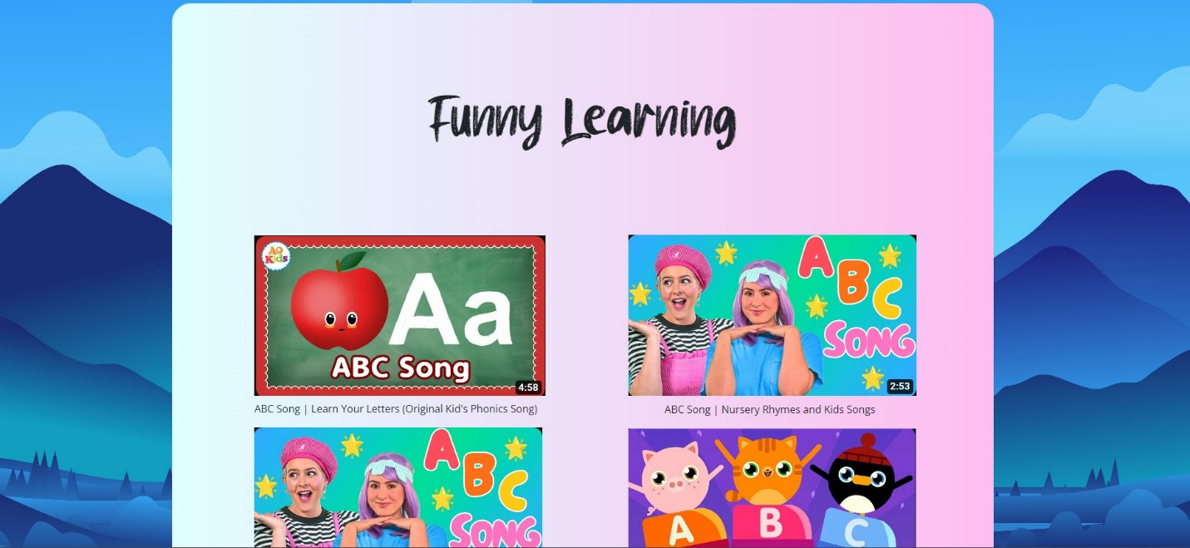  
- When you click on the box, you will go to the details page to play the video.

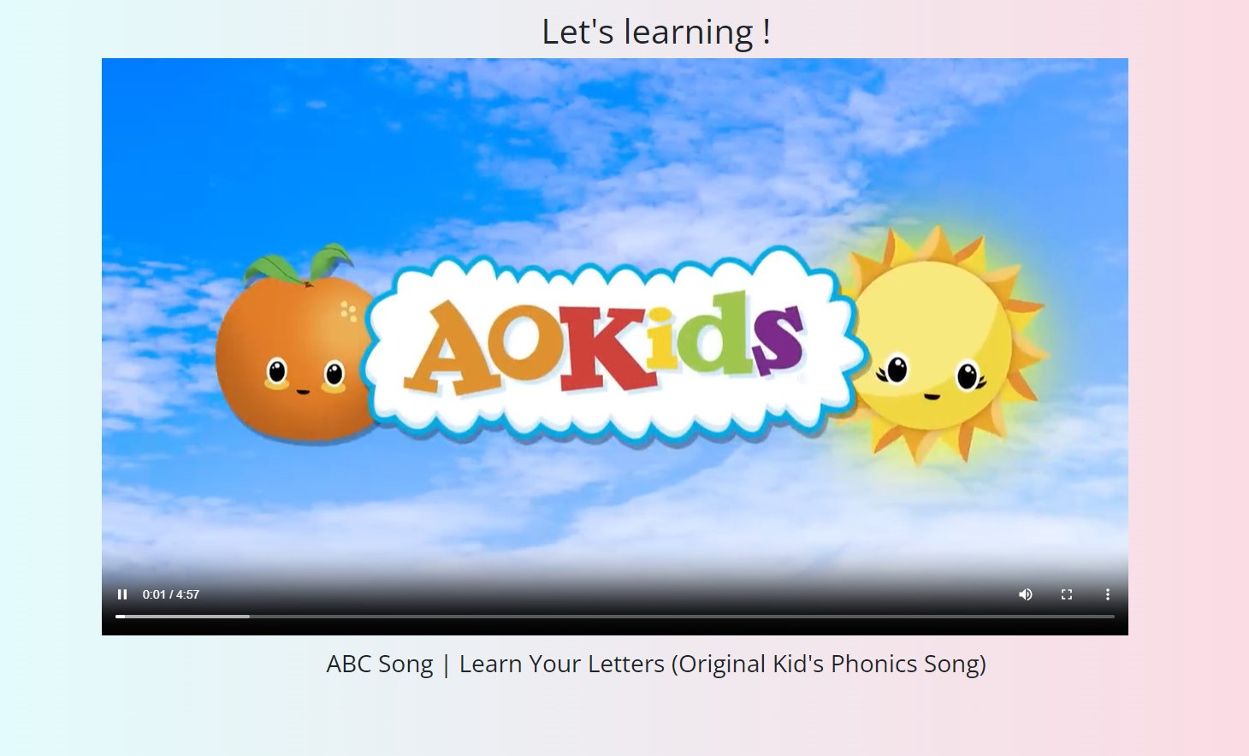

1. **About**

About us page have:

* Our story, our vision and a little information about school:

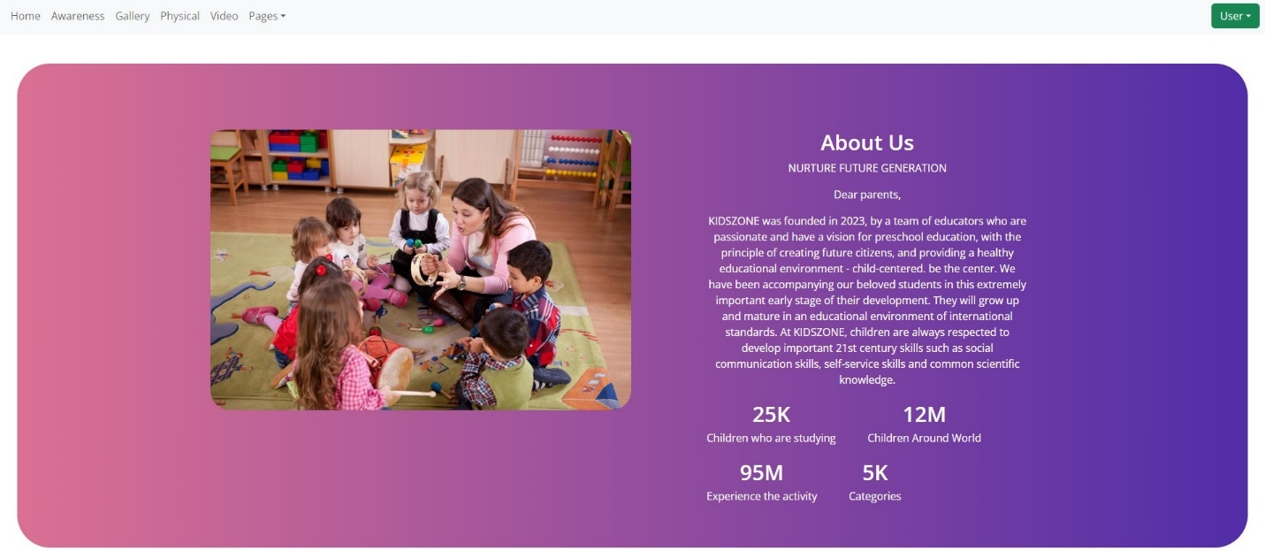

1. **Contact**

Contact page about:

* Location Store:

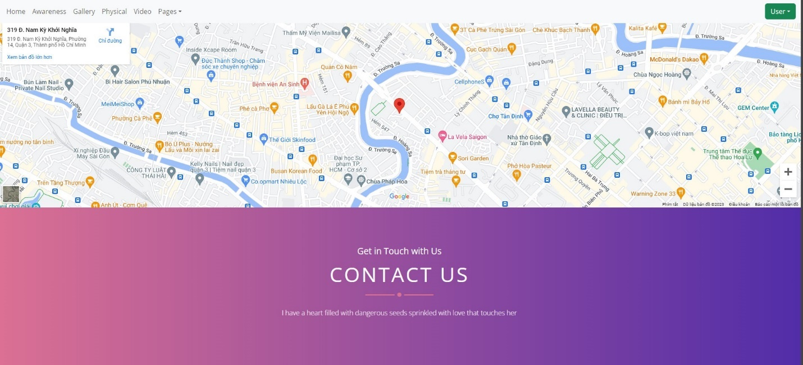

- Form that you can use contact with school:

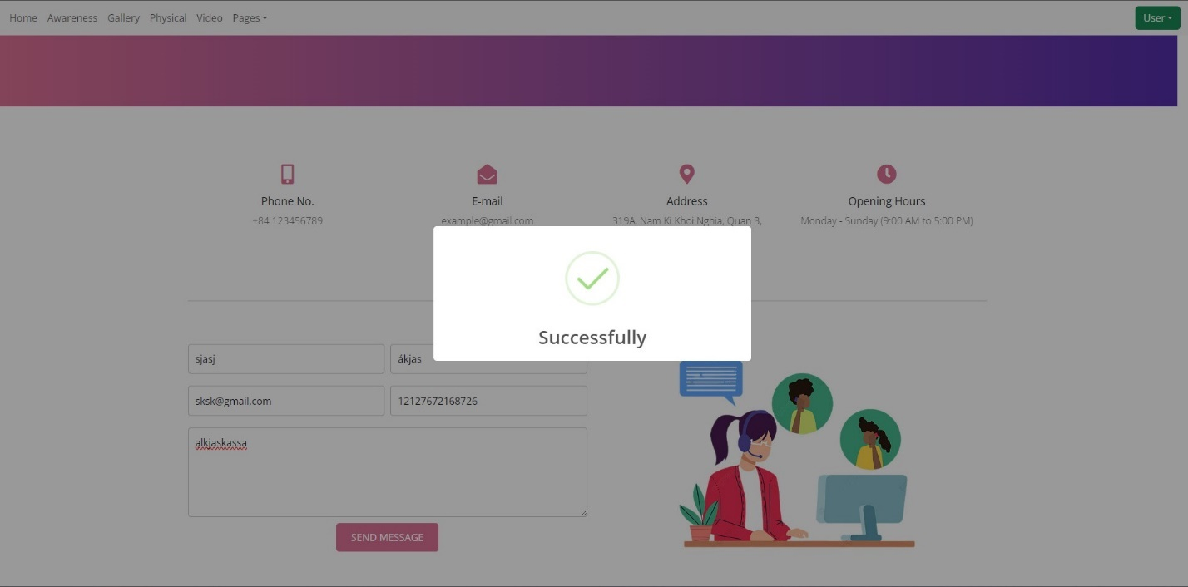

1. **Login/Logout**

- Login form and if login success.

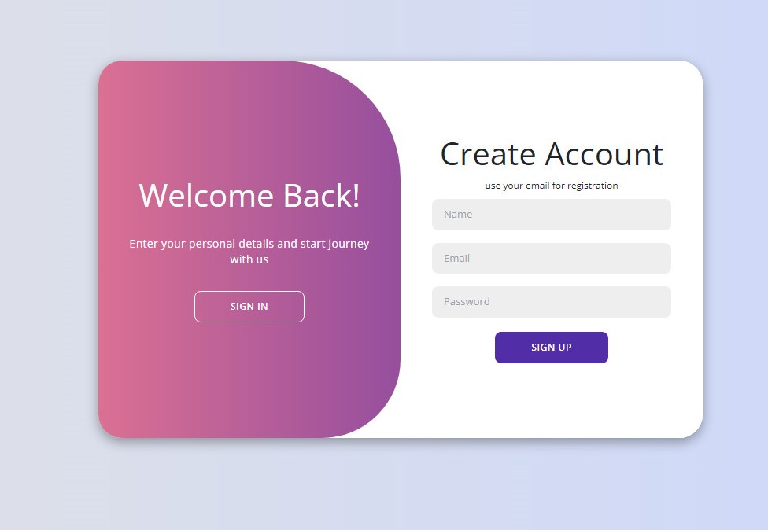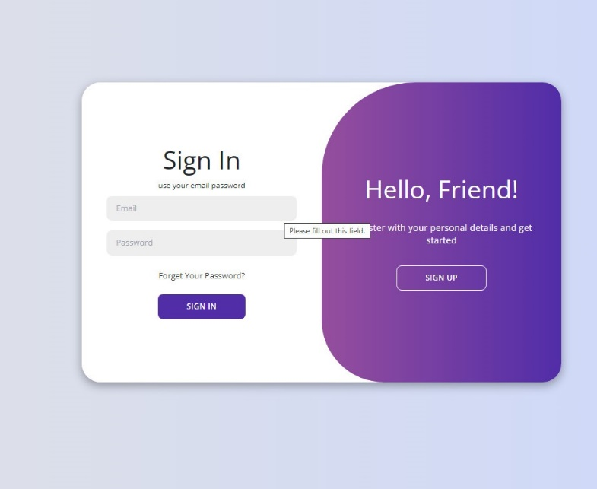

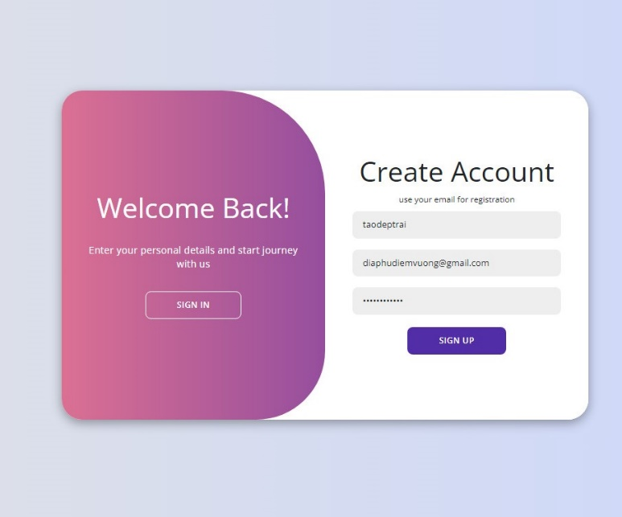

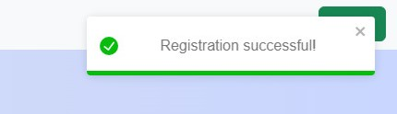

- Login form and if login fails.

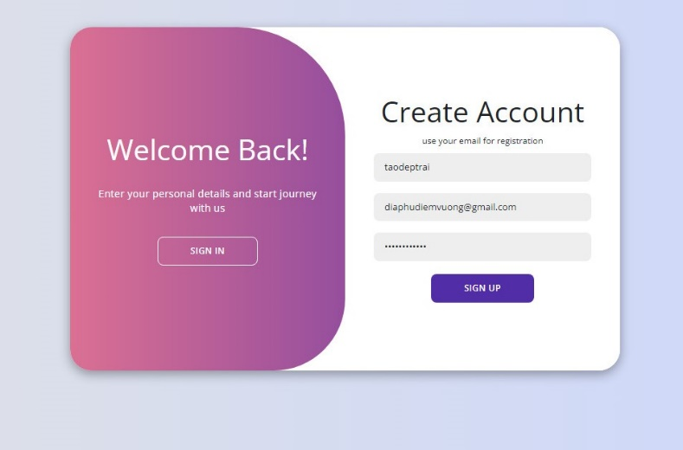

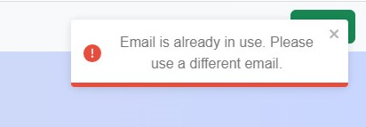

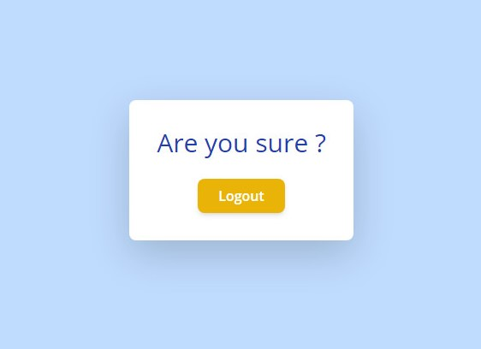- Logout:

Task sheet

|  |  |  |  |  |  |  |  |
| --- | --- | --- | --- | --- | --- | --- | --- |
| No | Member | Contents | Page Name | Activity Plan | Date of Preparation of Activity Plan | | |
| Planed Start Date | Actual Start Date | Actual End Date | Status |
|  | Nguyễn Hoàng Vĩ | Home page, LoginSignup page | Home.js, loginsignup.js | 24/11/2023 | 26/11/2023 | 22/12/2023 | 100% |
| Physical page | Physical.js | 24/11/2023 | 26/11/2023 | 22/12/2023 | 100% |
| Awareness: ABC, Math | Awareness.js | 24/11/2023 | 26/11/2023 | 22/12/2023 | 100% |
|  | Huỳnh Mai Thảo Vy | Contact, About Us | Contact.js, AboutUs.js | 24/11/2023 | 26/11/2023 | 22/12/2023 | 100% |
| Awareness:Animals | Awareness.js | 24/11/2023 | 26/11/2023 | 22/12/2023 | 100% |
| Gallery page | Gallery.js | 24/11/2023 | 26/11/2023 | 22/12/2023 | 100% |
|  | Nguyễn Gia Bảo | Awareness:ABC | Awareness.js | 24/11/2023 |  |  | 0% |
|  |  | 24/11/2023 |  |  |  |
|  | Nguyễn Hoàng Khánh Nhật | Video page | Video.js | 18/11/2022 | 26/11/2023 | 22/12/2023 | 100% |
| Awareness:Color | Awareness.js | 18/11/2022 | 26/11/2023 | 22/12/2023 | 100% |
| Logout page | Logout.js | 18/11/2022 | 26/11/2023 | 22/12/2023 | 100% |